Tutorial: Simulating Climate Futures in En-ROADS

Tutorial: Simulating Climate Futures in En-ROADS
Overview
Learning Objectives
About En-ROADS
Exercise
Impacts of Climate Change
The Baseline Scenario
Policies and Dynamics
1. Capital Stock Turnover Delay
2. Price and Demand Effects
3. Complementary Policies: Electrification
4. Economies of Scale and Learning
5. Competition between Energy Sources: “Crowding Out” and “Squeezing the Balloon”
6. Economic Damage from Climate Change
Protecting Forests, Land, and Food Choices
Addressing other greenhouse gases
Key takeaways from En-ROADS
Time to simulate and analyze your own scenario
The Climate Impact of AI in En-ROADS
Quiz review
En‑ROADS Resources to Learn More
Authors

Overview
In this tutorial, you will work with the En-ROADS simulation model developed by Climate Interactive and MIT Sloan to create a scenario that can mitigate global warming to the internationally agreed target of less than 2°C, and ideally 1.5°C. In addition, you will consider the economic, political, and social issues relevant to successful implementation of your policies.

Learning Objectives
By the end of this tutorial, you will:
- Gain a better understanding of the dynamics driving our energy, land, and climate systems.
- Use a system dynamics tool to visualize and understand complex behavior, such as:
  - Why the energy system changes slowly, and identify which policies act fast versus slow.
  - Why combining complementary policies (like renewable energy subsidy and electrification) produces a bigger effect than the sum of those policies.
  - How warming feeds back into the economy, and how that feedback affects the impact of other climate policies.
- Understand the relative leverage of certain policies and technologies—such as shifting food and diets, adding a carbon price, or subsidizing a new zero-carbon energy source—and the role they play in the global climate scenarios.
- Build and analyze your own En-ROADS scenario that limits warming to well below 2°C while weighing trade-offs in economic cost, equity, and environmental impact beyond climate.

Note: This is not a comprehensive tutorial of all the policy levers available in En-ROADS. To dive deeper into any given slider, you can read the slider sections of the User Guide. If you’re excited to learn more, take our training and learn how to use En-ROADS to facilitate workshops and role-playing games.

About En-ROADS
The En-ROADS Climate Solutions Simulator is a fast, powerful climate solutions scenario tool for understanding how we can achieve our climate goals through changes in energy, land use, consumption, agriculture, and other policies. The simulator focuses on how changes in global GDP, energy efficiency, technological innovation, and carbon price influence carbon emissions, global temperature, and other factors.

En-ROADS is designed to provide a synthesis of the best available science on climate solutions and put it at the fingertips of groups in policy workshops and roleplaying games. These experiences enable people to explore the long-term climate impacts of global policy and investment decisions. If you’re interested in learning how Climate Interactive uses the simulator with decision-makers to amplify its impact, read more here.

Please note: En-ROADS is a global model, which means that the policy levers simulate what would happen if the action were applied to the whole world. En-ROADS does not attempt to address the complex nuances of how different countries and political groups might respond to each policy.

The figure below shows the basic navigation features that you will need to use during this tutorial.
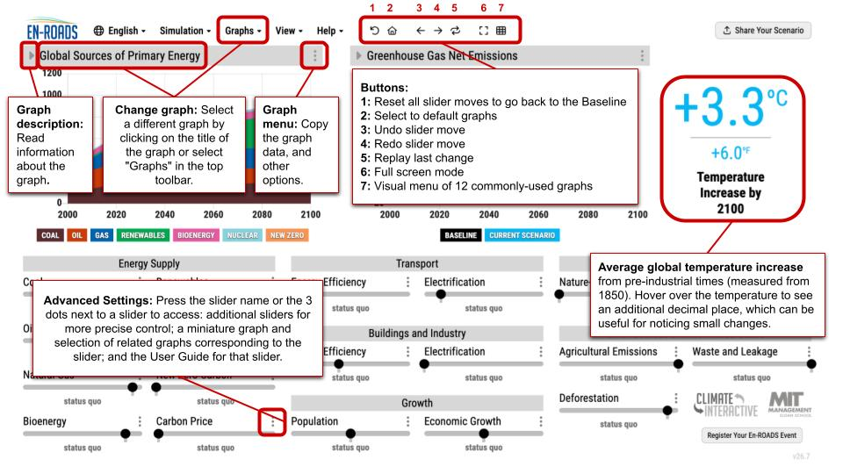
Figure 1: Basic En-ROADS navigation features

For more details on En-ROADS, such as the science behind it, how it works, and its limitations, read the section “En-ROADS Simulator Science.”

Exercise
- Open En-ROADS at en-roads.climateinteractive.org.
- Watch this video (10 minutes) to help you understand how to use the model: En-ROADS Overview and Introduction and review the Guide to the En-ROADS Control Panel.
- Read the sections below to learn more about the system dynamics in En-ROADS and get hands-on experience.

Impacts of Climate Change
Climate impacts refer to the effects of changes in the Earth’s climate on people, economies, ecosystems, and infrastructure. These include reduced crop yields, more deaths due to extreme heat, and lower economic growth. Impacts may be caused directly by temperature increase, or by associated drivers such as CO₂ concentration and sea level rise.

Test it yourself:
- In En-ROADS, pick two impacts (one for the left graph and one for the right graph) that you care most about, e.g., extreme heat and humidity days, sea level rise, air pollution from PM 2.5, etc. Click on the graph title to display the full list of graphs and maps and select one within the “Impacts” category.
Tip: click on “View as grid” to see the thumbnails for you to easily browse through the available graphs and maps in a visual way.
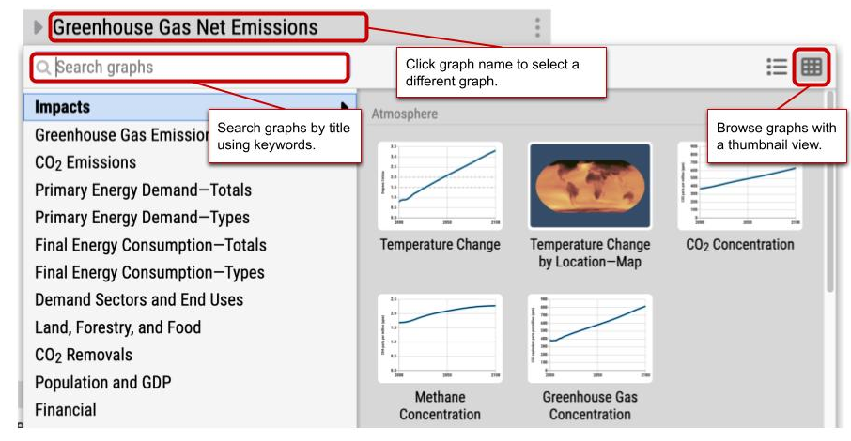
Figure 2: How to change and browse through the available graphs.

- Now build a scenario with many policy actions to limit warming to well below 2°C by 2100, and see how much better it gets. (You can see the warming amount to the right of the two graphs.)

Questions for reflection:
- Does this scenario limit the impact to a manageable level?
- How different are the impacts you viewed in the year 2050 or 2100 compared to the 2000s?
- Beyond the mitigation measures implemented in your scenario, will we need to invest in adaptation policies as well?

Big Messages:
- Climate impacts can highlight the importance of even a small change in temperature. Many impacts don't increase steadily as temperatures rise. Instead, they can become much worse very quickly.
- Mitigation brings co-benefits, which are apparent by comparing the impact late in the century in the Baseline vs. the Current Scenario.
- Limiting warming to less than 2°C is not without challenges either (we are already seeing impacts today). However, it is a benchmark by which scientists and world leaders believe we can lower the risks to a more manageable level.

Important note: We cannot adapt to an unmitigated world. We need to invest as much as possible in mitigation efforts, and then also adapt to the remaining impacts.

The Baseline Scenario

The En-ROADS Baseline Scenario represents the state of the world if societal and technological changes were to continue at their current rate of progress, without additional policies or action. The Baseline Scenario is designed to be a reasonable starting point from which to test various changes in policies and assumptions to see the impacts on our global climate. It is not a forecast of what is most likely to happen.

The Baseline Scenario in En-ROADS is the default scenario with no added policies or assumptions. Users can go back to the Baseline by clicking the “Reset policies & assumptions” button (#1 in Figure 1). On this trajectory, the world is on track to reach a temperature increase of 3.3°C by 2100 compared to pre-industrial levels. This is a global average; you can see the specific temperature increase in any location in the “Temperature Change by Location—Map” (under the “Impacts” category). Use the “Greenhouse Gas Net Emissions by Gas” graph to reveal the sources of the pollution causing this warming.
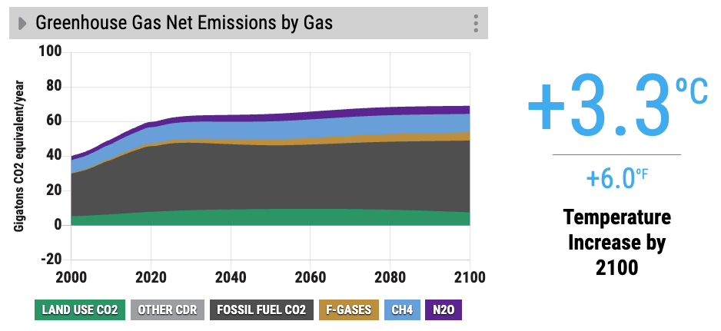
Carbon dioxide (CO₂), Methane (CH₄), fluorinated gases (F-gases) and nitrous oxide (N₂O) are all greenhouse gases that absorb radiation (heat energy) from the Earth’s surface and thus trap heat, causing global warming and climate change. Tip: you can read more about these gases and where they come from by clicking the small arrow next to the graph title.

Read more about the Baseline Scenario in the En-ROADS User Guide.

The Kaya Identity
Carbon dioxide from energy makes up roughly two-thirds of all greenhouse gas emissions. To explain what drives these emissions, En-ROADS uses the Kaya Identity, an equation developed by Yoichi Kaya. Go to View > Kaya Graphs to open the graphs below:
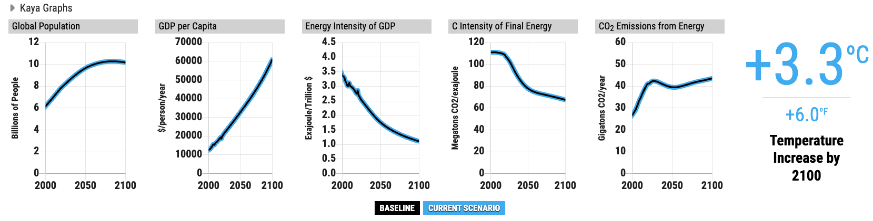
For each of the four factors, note what's happening in the Baseline Scenario:
- Global Population is growing—we are currently more than 8 billion people—to 10.2 billion by the end of the century, according to UN projections. The rate of growth is slowing over time as people have smaller families.
- GDP per Capita is growing steadily per year, and we assume it will continue, mostly as people in rapidly developing countries such as China, India, South Africa, Mexico, Brazil, and Indonesia attain higher standards of living.
- Energy Intensity of GDP is decreasing over time, due to the world economy becoming more efficient, or using less energy per unit of economic output. Technologies are improving—for example, more efficient cars, buildings, and machines—and economies are shifting from manufacturing to services. The product of global population, GDP per capita, and the energy intensity of GDP is the total amount of energy used by the global economy.
- Carbon Intensity of Final Energy, the amount of carbon dioxide emitted by energy use, is expected to slightly decline over time. Overall, this downward trend in carbon intensity is attributed to the gradual shifting away from fossil fuels and towards low-carbon energy sources.

Multiply all four factors above together and you get CO₂ emissions from energy. What do you notice?
Global Population × GDP per Capita × Energy Intensity of GDP × Carbon Intensity of Energy = CO₂ Emissions from Energy
Carbon Dioxide Emissions from Energy is the result of all four factors multiplied together, and you can see that in the Baseline Scenario, emissions are growing. Since the amount of CO₂ in the atmosphere correlates with temperature, rising concentrations drive rising global temperatures. The key takeaway is that improvements in efficiency and decarbonization aren't yet outpacing the growth in population and consumption.

Policies and Dynamics
The following sections will walk you through the system dynamics associated with policies in different climate-related sectors. Before starting each section, be sure to reset to the Baseline Scenario by clicking the “Reset policies & assumptions” button.

1. Capital Stock Turnover Delay
New energy sources (e.g., renewables and new zero-carbon energy sources) take decades (not years) to scale up sufficiently to compete with coal, oil, and gas globally. One of the main sources of these delays is that new energy infrastructure is generally only built when old infrastructure retires or there is a need to meet increased energy demand.

Only about 6% of all the world’s energy infrastructure changes each year, since infrastructure like coal-fired power plants and oil refineries can be used for 30 or more years. So while new zero-carbon energy sources may make up the majority of the market share of new energy capital, it will take many years for the old capital to turn over and be retired. The climate is only helped when coal, oil, and gas are retired, and in the absence of other interventions, that amount is relatively small—approximately 3% per year.

Test: Examine the “% Existing Transport by Carrier” and “% Transport Sales by Carrier” graphs (look at the gold lines). Move the Transport Electrification slider to be highly encouraged. What do you notice?

Answer: Even as the amount of electric transport grows, it takes several decades before it can reach over 50% of total transport. Compare this to the graph “% Transport Sales by Carrier” which rises much faster, as sales more immediately reflect the impact of the subsidy. View this Scenario in En-ROADS.

Key points to remember:
- The transition from high-carbon to low-carbon energy takes decades due to the long lifetime of fossil fuel capital infrastructure.
- This dynamic is also relevant to increasing energy efficiency or electrification. However, energy-using capital, such as vehicles, buildings, and industry, has an average lifetime that is much shorter (10-15 years).
- A new zero-carbon energy source takes too long to scale up to contribute much on its own to achieve our goal.
So what can we do about this?
- Keep investing in research and development of new and more efficient clean energy sources and energy-using capital that could play a role in the long-term, but simultaneously, double down efforts to decarbonize the existing supply in the next 10-20 years.
To learn more, view this video on the Capital Stock Turnover Delays.

2. Price and Demand Effects
Energy is a market like any other: demand shifts as price shifts. This simple relationship, the price-demand feedback loop, plays a bigger role in climate policy than you might expect.
Test: Go back to the Baseline Scenario by clicking the “Reset policies & assumptions” button and select the “Total Final Consumption of Energy Sources” and the “Average Price of Energy to Consumers” graphs. Move the Carbon Price slider to high (note, if you don’t know what a carbon price is, click the slider name and read the description). What do you notice?
Answer: The first thing you may notice is the big temperature drop from 3.3 to your current scenario. One of the reasons why a carbon price is a high-leverage solution is the price-demand feedback. Energy demand falls because energy prices increase (Scenario). People and companies are more likely to take actions to conserve energy (such as turning off the air conditioning or more efficient use of industrial heat), or invest in energy efficiency (such as buying energy-efficient appliances or insulating buildings) when energy prices are high.
Conversely, energy demand rises when prices fall. When a type of energy such as renewables or a new zero-carbon energy source is subsidized or experiences a breakthrough in cost improvement (Scenario), people and companies are less likely to take actions to conserve energy or invest in energy efficiency. The price-demand feedback loop explains one reason why subsidizing renewable and other zero-carbon forms of energy is less effective at reducing CO₂ emissions than one might expect.
Here are the key points to remember about this dynamic:
- Renewable energy or other low- or zero-carbon forms of energy only help the climate when they replace coal, oil, and gas, preventing those sources from emitting greenhouse gases.
- Subsidizing clean energy lowers overall energy costs, which raises demand. That extra demand eats into the low-carbon energy's ability to displace fossil fuels, and some of it gets met by fossil fuels directly.
- Actions that raise the cost of energy—like removing fossil fuel subsidies, taxing them, or adding a carbon price—work with little delay, making them high-leverage for near-term emissions.
So what can we do about this?
- Disincentivize fossil fuels, not just incentivize clean ones. Supply-side subsidies alone aren't the full clean energy solution.
- Once all energy is zero-carbon, rising demand won't matter for the climate, but until then, decarbonization has to come first.
- Design these policies to protect people with a high energy burden, ensuring access to affordable energy and efficiency upgrades.
To learn more, view this video on the Price-Demand Feedback Loop.

Note: A carbon price makes energy sources more expensive in proportion to their CO₂ emissions, offering an alternative to directly taxing coal, oil, and gas. Raising it has three notable effects: it hits coal hardest (the most carbon-intensive, and easiest to substitute away from), affects natural gas moderately and oil only slightly (since oil is harder to substitute—you can't run a diesel truck on solar), and makes bioenergy and renewables relatively more attractive, boosting their use. Like any price increase, it also reduces overall energy demand (the price-demand feedback loop). And because natural gas is largely methane, a carbon price indirectly cuts methane leakage too, by discouraging gas use and incentivizing leak repairs.

3. Complementary Policies: Electrification
Energy is delivered to users in different forms, or carriers. Electrification is an alternative to using fuels like oil or gas directly. In En-ROADS, graphs like "% Final Energy Consumption by Carrier" and "Final Consumption by End Use and Carrier" let you see the proportion of each energy carrier in use. View this Scenario in En-ROADS.
Renewables, nuclear, and new zero-carbon energy produce energy in the form of electricity in En-ROADS. Therefore, electrification of buildings and industry (for example, by switching from gas-powered heating to electric heat pumps) and transportation (switching from internal combustion engines to electric vehicles) is essential for using cleaner energy sources.
Test: View the “Renewables Primary Energy Demand” and “% Existing Transport by Carrier” or the “% Buildings & Industry Equipment Sales by Carrier” graphs, and create the three scenarios below to test the electrification sliders in En-ROADS. Take note of the reduced temperature from the Baseline Scenario. Tip: Hover over the temperature to see it to two decimal places. The difference here is subtle and won't show up at the default one-decimal view.
- Subsidize Renewables to the maximum. How much temperature increase was prevented?
- Reset to the Baseline Scenario, and then subsidize both Electrification sliders to the maximum. How much temperature increase was prevented?
- Now combine the three slider moves: Renewables, Transport Electrification and Buildings and Industry Electrification. How much temperature increase was prevented? What do you notice?
Answer: A renewables subsidy increases the Renewable Primary Energy Demand and displaces some of the fossil fuel use, modestly reducing warming (Scenario). It also slightly increases the sales of new electric transport and equipment because cheaper electricity is available. Electrification policies on their own help somewhat because electric vehicles and equipment are slightly more efficient than their fuel-based alternatives, and because they indirectly favor clean energy growth and reduce some oil consumption (Scenario). A renewables subsidy combined with electrification policies reduces warming slightly more than the sum of the policies in isolation (Scenario).

4. Economies of Scale and Learning
Costs for energy supplies like renewables fall because of experience. As cumulative installed capacity grows, costs drop through a reinforcing feedback loop, the learning loop, sometimes called economies of scale.
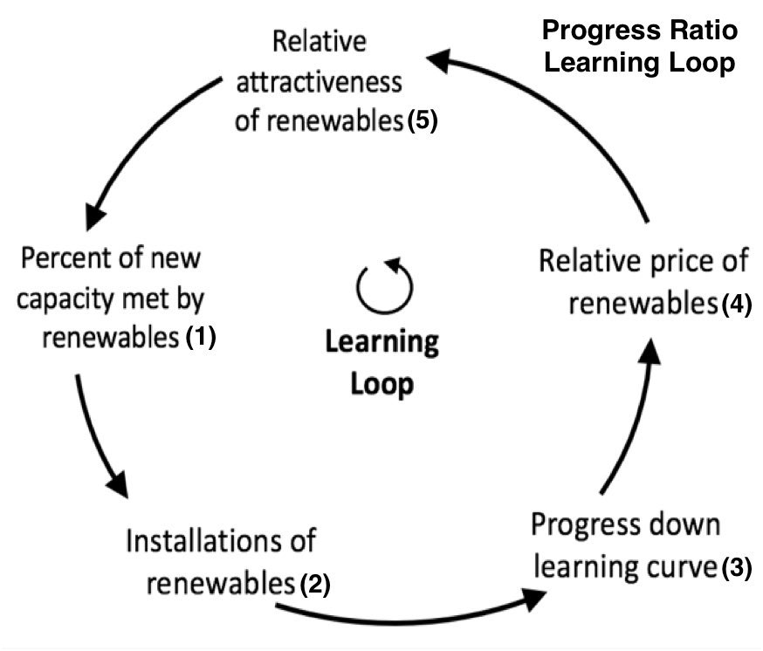
Test: Look at the "Renewables Primary Energy Demand" graph and move the Renewables subsidy slider higher. What do you notice?
Answer: Renewables grow with a steep exponential curve through the 2040s. That's the learning loop at work: more installed capacity leads to more learning, which lowers price, which makes renewables more attractive, which drives even more capacity and installation. View this scenario in En-ROADS.
This dynamic is called Economies of Scale: More production builds experience, capacity to build more, and research & development advances, which lowers cost, and the cycle continues. This happens to all energy supplies and all new technological advancements in general, but it’s especially helpful when describing why renewable energy, such as wind and solar, is expected to grow so much in the Baseline Scenario.
Every doubling of cumulative installed renewable capacity lowers costs by roughly 20%—a relationship known as the "progress ratio" (a slider that can be changed under Simulation > Assumptions > Energy supply progress ratios). For comparison, coal's progress ratio means only about a 2% cost reduction per doubling, since coal has already captured most of its efficiency gains over the past century.
This feedback is some of the best recent news for the climate. Look at the Marginal Cost of Electricity Production graph to see how wind and solar energy are globally on average as cheap as coal. In many places in the world, wind and solar are the cheapest energy resources. Look at the historical graphs for wind and solar growth to understand why even without additional subsidies, En-ROADS Baseline projects a substantial growth of Renewables capacity.
Here are the key points to remember about this dynamic:
- Renewable costs don't just fall because of subsidies—they fall because of experience. More installed capacity means more learning, which lowers cost, which drives more installation: a reinforcing loop.
- This "progress ratio" is steep for renewables (~20% cost reduction per doubling of capacity) but shallow for mature technologies like coal (~2%), since coal has already captured most of its efficiency gains.
- This is why renewables are projected to grow so much in the Baseline Scenario even without additional policy. The learning loop is already running on its own momentum.
- Subsidies don't just lower cost directly. They also speed up the learning loop itself, by accelerating the accumulation of installed capacity and experience.
To learn more, view this video on Economies of Scale.

Notes for hope:
- Don't be discouraged if a renewables subsidy alone shows only a modest effect. The reason is that the Baseline already builds in substantial renewables growth from this dynamic, so a subsidy is accelerating a trend already in motion, making an already cheap energy source only a little cheaper.
- By now, this points to one of the tutorial's biggest insights: it takes many seeds to plant a garden. No single policy—not even one as powerful as renewables—gets us there alone. We need many solutions working together, and every tenth of a degree we prevent matters.

5. Competition between Energy Sources: “Crowding Out” and “Squeezing the Balloon”
Energy sources compete with each other for market share, and when a source of energy is “squeezed” like a balloon, others “pop up” to compensate.
Test: To see the competition of energy sources in action, create the three scenarios below and take note of the shaved off temperature from the Baseline Scenario. Tip: To view the temperature in 2100 to two decimal places, hover over the temperature with your mouse.
- Scenario with a high Renewables subsidy. How much temperature increase was prevented?
- Scenario with a huge breakthrough in New Zero-Carbon. How much temperature increase was prevented?
- Scenario with a high Renewables subsidy and a huge breakthrough in New Zero-Carbon combined. How much temperature increase was prevented?
Answer: The combined warming prevented by implementing a Renewables subsidy and a New Zero-Carbon subsidy together is actually less than the sum of the two individual reductions, because the energy sources compete with each other for market share rather than each contributing its full, independent effect.
Test: To see the opposite effect, try a scenario that heavily taxes coal, and look at the "Global Sources of Primary Energy" graph. What do you notice?
Answer: Coal use drops sharply, as expected (Scenario), and other sources increase to partly fill the gap. Look at “Natural Gas Primary Energy Demand” and “Renewables Primary Energy Demand” graphs (Scenario). Coal is now more expensive, and hence is substituted by other cheaper energy sources. Squeeze one part of the energy balloon, and another part bulges out to compensate. This is the flip side of the same dynamic as above: energy sources aren't just competing with each other, but they're also ready to substitute for each other when one gets squeezed.
Here are the key points to remember about this dynamic:
- Crowding Out: Energy sources compete with each other. Increasing one energy source causes other energy sources to decrease.
- Squeezing the Balloon: Since energy needs to come from somewhere, decreasing one energy source (such as coal) causes another energy source to increase (such as natural gas and renewables).
- To avoid shifting demand from one fossil fuel to another, we need a policy that raises the cost of all fossil fuels together, not just one at a time.
To learn more, view this video on "Crowding Out and Squeezing the Balloon."

6. Economic Damage from Climate Change
Warming doesn't just affect the climate—it feeds back into the economy, which feeds back into emissions. Rising temperatures are linked to more frequent climate disasters, lower crop yields, and other damages that reduce GDP growth and global energy consumption. This is a balancing feedback loop, where less consumption means fewer emissions, which means somewhat less future warming. Estimates of how much climate change damages the economy (the "damage function") vary a lot between studies, and you can select a higher or lower damage pathway under the Assumptions menu.

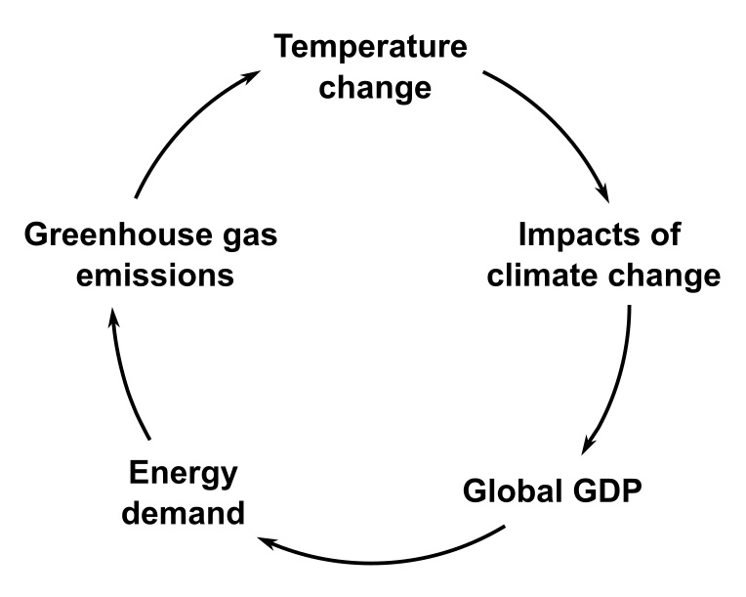
Test: View this scenario and toggle the "Climate change slows economic growth" switch under Simulation > Assumptions > Economy > Economic impact of climate change, on and off. What do you notice?
Answer: With the switch off, the economy keeps growing unaffected by climate change, which causes more greenhouse gas pollution and more warming. (Note that within the En-ROADS simulator, this only changes your Current Scenario; the Baseline Scenario always includes this economic damage effect.)
This feedback loop explains a counterintuitive pattern you may run into while building your own scenario: any action that lowers temperature without changing energy costs or efficiency—like carbon removal, or cutting agricultural emissions or waste—will slightly increase energy consumption. Lower temperature means less economic damage, which means higher GDP growth, which means more energy use. If all energy were already zero-carbon, this wouldn't matter for the climate—but today it does.
To learn more, read the Explainer on the Economic Impact of Climate Change in En-ROADS.

Protecting Forests, Land, and Food Choices
So far we have focused mostly on the energy and economy dynamics, but there are other solution sectors to explore in En-ROADS. Forests are one of the planet's biggest natural carbon sinks—trees and soils pull CO₂ out of the atmosphere and store it for decades. Protecting forests does two things at once: it stops the release of carbon that's already locked up in trees and soil, and it keeps that land actively removing more carbon going forward.
Test: Look at the "CO₂ Net Emissions from Land Use" graph (under Graphs > CO₂ Emissions) and the "CO₂ Uptake and Removals from Land" graph (under Graphs > CO₂ Removals). Move the main Deforestation slider to its maximum reduction rate. What do you notice?

Answer: View this scenario in En-ROADS. Net emissions from land use drop, since less forest is being cleared. In addition, CO2 removals from land go up, as forests left standing keep absorbing carbon as they continue to grow. Less carbon released, more carbon absorbed. You can see both effects together in the "CO₂ Emissions, Uptake and Removals" graph (also under Graphs > CO₂ Removals).

Why are forests being lost in the first place?

Most deforestation is driven by the need for more cropland. That demand, in turn, is shaped by population growth, economic growth, and how much food is produced per acre—but it's also strongly shaped by what the world chooses to eat and how much food gets wasted. Shifting toward more plant-based diets and reducing food waste both lower the demand for new farmland, which directly reduces pressure to clear forests.

Test: Go back to the Baseline Scenario and open the “Total Agricultural Production” and "Forest Area" graphs (under Graphs > Land, Forestry, and Food). Under Agricultural Emissions (click on the title, and a popup will come up), try adjusting the “Food from animals” and “Food waste” sliders. What do you notice? Now open the “Methane Emissions” and “N₂O Emissions” graphs. Can you guess why these emissions are lower in this scenario?

Answer: View this scenario in En-ROADS. Even modest shifts in food and diets show up as changes in forest area. Producing animal-based foods uses more land and fertilizer, on average, than plant-based foods. Plant-based diets also cut methane emissions from cows and other ruminants. Reducing food waste—currently about a quarter of global food production—saves land, water, and fertilizer.

Notes:
- Forest degradation—the gradual loss of mature, old-growth forest through harvesting for wood, paper, or bioenergy—matters because old-growth forests store large amounts of carbon. Once degraded, that carbon takes decades to reaccumulate even if the forest is allowed to regrow. You can control forest degradation using the main “Deforestation” slider or the advanced “Reduction in mature forest degradation” slider underneath, and see the dynamics using the "Forest Area by Age" graph.
- Afforestation or reforestation—planting forest on land that wasn't previously forested, or replanting where a forest was degraded—can be tested under the Nature-based Carbon Removal slider. Explore the "Land for CO₂ Removal" and "Sources of Anthropogenic CO₂ Removals" graphs, and move the "Percent available land used for afforestation and reforestation" slider to see the effects. View this scenario in En-ROADS.
- Better agricultural practices can lower the emissions intensity of the food produced. The “Agricultural Emissions” slider is a powerful lever that can lower methane (CH₄) from sources like cows and rice paddies, and nitrous oxide (N₂O) from fertilizers and manure.

Key points to remember:

- Protecting existing forests from deforestation and degradation avoids releasing locked-in carbon and boosts ongoing carbon removal.
- Mature forests (over 100 years old) store far more carbon than young ones. Degrading them creates a carbon debt that takes decades to repay as replacement trees regrow.
- Forests alone can't solve climate change given the scale of fossil fuel emissions, but protecting them is one of the fastest-acting, most cost-effective actions available, and it comes with major co-benefits for biodiversity and ecosystems.
- Diet and food-waste policies matter for the climate, although, as it happens with every single other solution, they need to be complemented with many other policies across other sectors.

To learn more, read the Land and Forests in En-ROADS explainer and the Food and Agriculture in En-ROADS explainer.

Addressing other greenhouse gases
Methane (CH₄), nitrous oxide (N₂O), and fluorinated gases (F-gases) together make up about a quarter of global greenhouse gas emissions today. Some of the levers that affect these gases were covered in the section on “Protecting Forests, Land, and Food Choices” above, and more levers are underneath the Agricultural Emissions and Waste and Leakage sliders.
These gases are very important to address because they trap more heat per unit of weight than CO₂, and some persist in the atmosphere for a long time. If the world focuses decarbonization efforts on energy alone, non-CO₂ gases could make up the larger share of future emissions. Reducing them is high-leverage, and it comes from actions such as: better livestock and manure management, methane leak detection and repair in oil and gas systems, improved waste and wastewater management, and replacing potent F-gases with other refrigerants.
To learn more, read the Methane in En-ROADS explainer, the Food and Agriculture in En-ROADS explainer, the article: Nitrous Oxide: No Laughing Matter for the Climate and Ozone Challenge, and the “How do I reduce F-gas emissions, simulating policies like the Kigali Amendment to the Montreal Protocol or a similar policy?” FAQ.

Key takeaways from En-ROADS
- A combination of solutions is needed to address climate change: “It takes more than one seed to plant a garden.”
- Keeping climate change to well below 2°C, and limiting it to 1.5°C, is possible. We can still avoid the worst-case scenarios—it is still physically and technologically possible.
- All successful scenarios cut the burning of coal, oil, and natural gas in the next 10-20 years. Many policies can be implemented to reduce the dependence on fossil fuels. For example:
  - A carbon price is high leverage because it changes the fuel mix and reduces energy demand with little delay.
  - We can start by reducing the existing subsidies to coal and natural gas and substituting them for subsidies to clean energy.
- Reducing other greenhouse gas emissions (methane, nitrous oxide, and F-gases) reduces temperature quite a bit.
- Energy efficiency is a high-leverage policy because it reduces the energy intensity of economic activities.
- Protecting forests not only avoids releasing locked-in carbon into the atmosphere, but it also increases the capacity of the land to remove additional carbon. There are also widespread benefits to biodiversity, animal habitats, hydrological systems, and more.
- There are many opportunities to increase equity as we take these actions.

Time to simulate and analyze your own scenario
So far, you may have noticed that none of the levers alone get us to our global goals fast enough. But layered together, they can add up to a realistic path below 2°C. That's what you'll build next.

- Build a scenario to meet your goals. Use En-ROADS to develop your vision of how to successfully limit global warming to less than 2°C and ideally closer to 1.5°C, per the Paris Agreement. Aim to balance these additional goals as you build your plan:
  - Support a healthy economy: Weigh short-term costs against long-term costs of inaction.
    - As you analyze your scenario, look at the “Marginal Cost of Electricity Production”, “Revenue & Cost from Energy Taxes & Subsidies”, and the “Price of…” graphs under Graphs > Financial.
  - Promote equity: consider the equity implications of the different policies and how they could be designed to avoid harming the most vulnerable.
    - Many equity considerations can't be observed directly in graphs, but can be read about in the User Guide sections for each of the sliders.
  - Consider impacts on water, air, and biodiversity.
    - You can explore the “Air Pollution from Energy by Source — PM2.5”, “Loss in Ocean Life from Warming”, “Extinction Risk of Endemic Species”, and “Species Losing More than 50% of Climatic Range” graphs.
  - Stay realistic, not cynical: Aim for what's achievable.
    - Note, this is somewhat subjective. En-ROADS also makes assumptions based on the best available research studies to determine what’s reasonable. If you don’t agree with some of the Assumptions, many can be changed under the Simulation > Assumptions menu.
- Optional write up: After developing your preferred scenario, you can write your takeaways using the questions below as guidelines.
  - Winners/Losers: Who would be the biggest winners and losers globally in your proposed future? Create a table with two columns for winners and losers.
  - Surprises: What surprised you about the behavior of the energy and climate system as captured in En-ROADS? For example, what actions had a bigger or smaller effect than you thought?
  - Hope: What trends in the world give you hope that your proposals are possible?
  - Personal Action: What can you personally do to help create the necessary changes?
- You can submit your writeup in LearnWorlds. Include your scenario link by copying it from the top right button: Share Your Scenario > Copy scenario link.

The Climate Impact of AI in En-ROADS
En-ROADS models the energy demand and emissions from data centers, including emissions driven by AI, letting you explore how that demand grows over time, what's driving the growth, and how it shapes global emissions and temperature.

However, as of July 2026, En-ROADS does not model AI's potential to accelerate the adoption of climate solutions, or its use in improving efficiency and reserve-finding in the oil and gas sector. You can read how to approximate these scenarios using current sliders as a proxy in the FAQs on this topic.

To dive deeper on this topic, read the Data Centers and AI in En-ROADS explainer.

En‑ROADS Resources to Learn More
Knowledge Base: Access additional FAQs on En‑ROADS including explainers on specific topics included in the model and details about model dynamics.
User Guide: Use this overview of En‑ROADS to learn to navigate the simulator and interpret results.
Free Training: Participate in our interactive training program to learn En‑ROADS and explore the dynamics of climate policy.
Technical Reference: For those who want to dive into the modeling details, explore the comprehensive guide to the model’s equations, assumptions, and methodologies.
En-ROADS Simulator Science: Read details on how the simulator works, how it is tested, and more.

Authors
Author: Clara Iglesias, Project Manager at Climate Interactive

Reviewers:
- Janet Chikofsky, Project Manager at Climate Interactive
- Priya Donti, MIT and Climate Change AI

